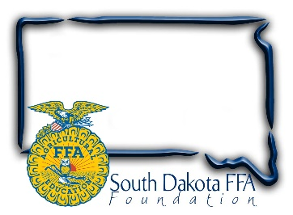
For Immediate Release
Contact: Gerri Ann Eide
605-765-4865
Gerri@sdffafoundation.org

FFA members package 50,184 meals during Living to Serve Day
(Bath, SD) – April 19, 2023– The blue corduroy jacket is a familiar symbol of the FFA organization, worn as part of official dress during most FFA activities. On April 17th at the South Dakota FFA convention in Brookings, as part of a SD FFA Living to Serve Day, members removed their jackets and rolled up their sleeves to help stop hunger in South Dakota.
This service project, supported by funds from Pioneer-Corteva, Rick & Sandy Osterday, and a grant from the National FFA Foundation exemplified the portion of the FFA motto which states “Living to Serve” by teaming up with industry to fund a Meals of Hope, hands on project that combats hunger. SD FFA members and Pioneer-Corteva staff measured, poured, sealed, and boxed 50, 184 meals in assembly line fashion throughout the day-long event. Members stopped in between workshops and competitive events throughout convention and left the event knowing that by giving a few minutes of their time they would make a significant difference in the life of a person less fortunate than themselves.
The Meals of Hope food packages are a hardy Pasta and Tomato Sauce meal. All of the 50,184 meals were donated to Feeding South Dakota based in Sioux Falls and will be distributed across our state by Feeding South Dakota. Dan Carlson and Cullen Winter with Feeding South Dakota attended the event, Dan said “This is a very impressive event, it’s wonderful seeing the FFA members giving their time to package these meals”. He also stated, with the huge demand they see for food, these meals will be consumed quickly, he estimated that the supply will last approximately 30 days. The Feeding South Dakota program is very thankful for this donation from the FFA.
“The FFA organization believes strongly in the fourth line of the FFA Motto "Living to Serve", which is why we are very excited to receive funds from both Pioneer-Corteva as well as day of event manpower assistance and interaction from their staff,” says Sandy Osterday, SD FFA Foundation President. Osterday shares, “The event gives students the opportunity to work together with FFA members from across the state to make items that will help those in need. Knowing we are helping those in need across our state is a great feeling.”
The SD FFA Foundation is proud to support Agricultural Education and the FFA's mission to make a difference in the lives of students by developing their potential for premier leadership, personal growth and career success through agricultural education. For more information about the South Dakota FFA Foundation and South Dakota's FFA programs, visit www.sdffafoundation.org or follow us on Facebook.
Photos: FFA members from across the state work together to measure, package and seal meals during the Day of Service, Meals of Hope Project at State FFA Convention.
# # #

